1. Interrupt classification
a. Interrupt (asynchronous)
Generated by I/O device, clock or other cpu. The interrupt from I/O can be maskable and non-maskable interrupt for hardware fault.
b. Exception (synchronous)
Generated by CPU, caused by program error, fault (page), trap (debug).
Such as Divide error, Overflow, NMI and so on.

Each interrupt and exception can be presented by an unsigned char from 0~255 which name is vector. The vectors of nonmaskable interrupt and exception are fixed. The vector of maskable interrupt can be changed through Interrupt Programmable Control.

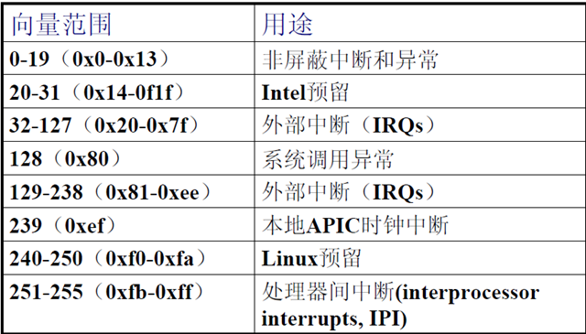

2. Hardware interrupt
a. IPC
1). Interrupt Programmable Control

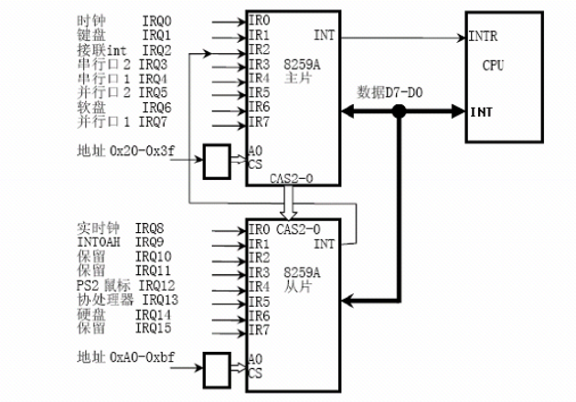

There is an IRQ (Interrupt Request) Line connecting to IPC on each I/O device.
PIC actions.
a). The IPC supervise the IRQ line to check the raised signal.
b). Convert the signal to a vector and save it to an I/O port so that CPU can read it via data bus.
c). Send the signal to CPU INTR and trigger an interrupt.
d). Wait CPU ack the interrupt signal and clear INTR.

In default for I/O device the IRQ Line + 32 is equal vector in x86.

2). Advance Interrupt Programmable Control for SMP

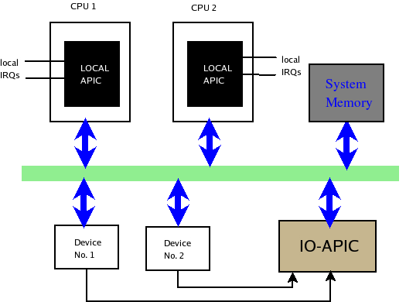
Each I/O interrupt can be assigned to one or several CPUs.

b. interrupt handled
1). Interrupt Descriptor Table
IDT is used by the processor to determine the correct response to interrupts and exceptions. It is an interrupt vector array with size 256. Each entry (vector) is a gate descriptor with 8 bytes and stores the Exception/Interrupt handling Routing of related vector .
idt_table stores in IDTR register.

gate_desc idt_table[NR_VECTORS] __page_aligned_data = { { { { 0, 0 } } }, };
typedef struct desc_struct gate_desc;
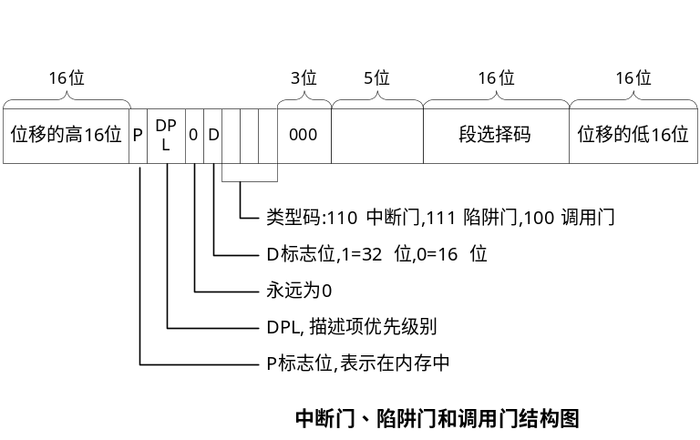

IDT actions
a). Get the interrupt vector n;
b). Read the IDTR register and get the n+32 entry.
c). Get the segment base pointer by the segment selector, gdtr register.
d). Validate the CPL and DPL.
e). Save eflags, cs, eip in the stack.
f). Load cs and eip from interrupt vector. (First instruction of Interrupt/Exception Handling Routing)
e). After ISR, iret called.

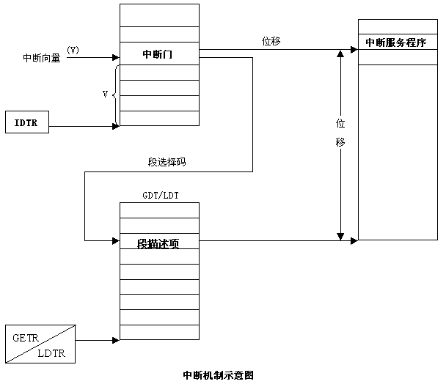

2). I/O interrupt

a. initialization

early_irq_init(void)
{
//allocate irq descriptor: see below
for (i = 0; i < initcnt; i++) {
desc = alloc_desc(i, node, NULL);
set_bit(i, allocated_irqs);
irq_insert_desc(i, desc);
}
}
init_IRQ()
{
x86_init.irqs.intr_init();
/*native_init_IRQ();*/
}

/*set interrupt[] array as the related vector Interrupt Handling Routing, make up a gate_desc and insert to the idt_table */
void native_init_IRQ(void)
{
/*setup some apic related vector */
apic_intr_init();
/* alloc_intr_gate(LOCAL_TIMER_VECTOR, apic_timer_interrupt);*/

/*
* Cover the whole vector space, no vector can escape
* us. (some of these will be overridden and become
* 'special' SMP interrupts)
*/
i = FIRST_EXTERNAL_VECTOR; //0x20
for_each_clear_bit_from(i, used_vectors, NR_VECTORS) {
/* IA32_SYSCALL_VECTOR could be used in trap_init already. */
set_intr_gate(i, interrupt[i - FIRST_EXTERNAL_VECTOR]);
}
}

interrupt array is defined in arch/x86/kernel/entry_32.S

ENTRY(interrupt)
………
jmp common_interrupt
common_interrupt:
addl $-0x80,(%esp) /* Adjust vector into the [-256,-1] range */
SAVE_ALL
movl %esp,%eax
call do_IRQ
jmp ret_from_intr

The Interrupt Handling Routing of all the I/O interrupts will call to do_IRQ with different vector.

b. handling
The interrupt runs, acknowledges the hardware, copies the new data from hardware I/O into main memory, and modify hardware register to ready the new data. These jobs are the important, time-critical, and hardware-specific work.

Three types operation:
1). Critical: ack the interrupt to PIC. It is handled by irq_chip in disable irq environment.
2). Non-critical: modify device register data. It is handled by ISR of each device in enable irq environment but mask the same irq signal.
3). Non-critical deferrable: copy the content from device buffer to memory. It should be handled in the softirq.

i). do_IRQ

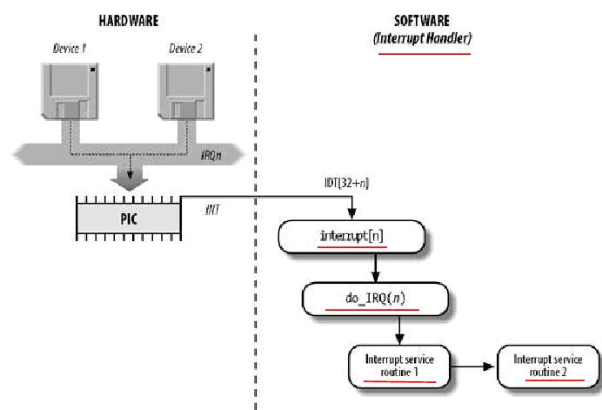

/*do_IRQ is running in the irq_disable environment when call the each ISR it may be enable_irq */
nsigned int __irq_entry do_IRQ(struct pt_regs *regs)
{
struct pt_regs *old_regs = set_irq_regs(regs);

/* high bit used in ret_from_ code */
unsigned vector = ~regs->orig_ax;
………
if (!handle_irq(irq, regs)) {
ack_APIC_irq();
}
…………
}

ii). irq descriptor
struct irq_desc {
struct irq_data irq_data;
/(it contains some irq information*/
/* it also contains irq_chip: manage the irq ack and mask set_affinity*/

irq_flow_handler_t handle_irq;
struct irqaction *action; /* IRQ action list */
........
};
struct irqaction {
irq_handler_t handler; /*ISR of each I/O device*/
.........
};

bool handle_irq(unsigned irq, struct pt_regs *regs)
{
desc = irq_to_desc(irq);
……
desc->handle_irq(irq, desc);
……
}

handle_irq is set by system probe :
//TODO difference
handle_edge_irq
handle_fasteoi_irq
handle_level_irq
handle_edge_eoi_irq

In the io_apic subsystem, it will set the related irq descriptor handle and irq_chip. Such as ioapic_chip, hpet_msi_type, msi_chip.

All the function will call handle_irq_event.

void handle_xxx_irq(irq, *desc)
{
/*ack irq*/
desc->irq_data.chip->irq_ack(&desc->irq_data);
do {
if (unlikely(!desc->action))
goto out_eoi;

handle_irq_event(desc);

} while ((desc->istate & IRQS_PENDING) &&
!irqd_irq_disabled(&desc->irq_data));
}

handle_irq_event(struct irq_desc *desc)
{
struct irqaction *action = desc->action;
irq = desc->irq_data.irq;

do {
irqreturn_t res;
res = action->handler(irq, action->dev_id);
/*driver can register the handler with request_irq*/
retval |= res;
action = action->next;
} while (action);
}

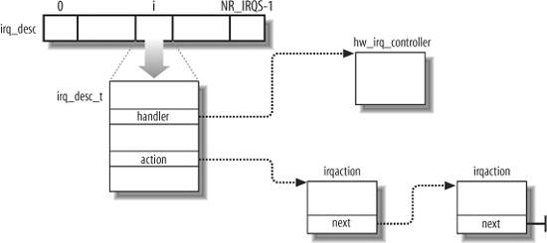

Regist irq action
request_irq(): to regist a irq action on a irq line.
flags:
IRQF_DISABLED:When set, this flag instructs the kernel to disable all local interrupts when executing this interrupt handler.When unset, interrupt handlers run with all interrupts except their own enabled.
IRQF_SHARED:This flag specifies that the interrupt line can be shared among multiple interrupt handlers. Each handler registered on a given line must specify this flag; otherwise, only one handler can exist per line.

Interrupt handlers in Linux need not be reentrant. When a given interrupt handler is executing, the corresponding interrupt line is masked out on all processors, preventing another interrupt on the same line from being received. Normally all other interrupts are enabled, so other interrupts are serviced, but the current line is always disabled. Consequently, the same interrupt handler is never invoked concurrently to service a nested interrupt.

Interrupt control
a. Enable to disable the interrupt system for the current processor
local_irq_disable(); local_irq_enable();

local_irq_save(flags); /* interrupts are now disabled */
/* ... */
local_irq_restore(flags); /* interrupts are restored to their previous state */

the call to save and the call to restore interrupts must occur in the same function

b. mask out an interrupt line for all the processors.
void disable_irq(unsigned int irq);
void enable_irq(unsigned int irq);

c. status
in_interrupt() Returns nonzero if in interrupt context and zero if in process context
in_irq() Returns nonzero if currently executing an interrupt handler and zero otherwise

3) exception: init before I/O interrupt

void trap_init()
{
set_intr_gate(X86_TRAP_DE, &divide_error);
set_intr_gate_ist(X86_TRAP_NMI, &nmi, NMI_STACK);
set_system_intr_gate(X86_TRAP_OF, &overflow);
………

/*X86_32 syscall using interrupt ways*/
#ifdef CONFIG_X86_32
set_system_trap_gate(SYSCALL_VECTOR, &system_call);
set_bit(SYSCALL_VECTOR, used_vectors);
#endif
}

The divide_error, overflow, system_call functions are directly set as ISA.

The definition of these functions is in arch/x86/kernel/erntry_32.S

ENTRY(overflow)
RING0_INT_FRAME
ASM_CLAC
pushl_cfi $0
pushl_cfi $do_overflow
jmp error_code
CFI_ENDPROC
END(overflow)

error code:
restore_all
……
jmp ret_from_exception

4). ret_from_xxx

ret_from_exception:
preempt_stop(CLBR_ANY)/*disable preempt*/
ret_from_intr:
movl PT_CS(%esp), %eax
andl $SEGMENT_RPL_MASK, %eax
cmpl $USER_RPL, %eax /*get RPL*/
jb resume_kernel
ENTRY(resume_userspace)
LOCKDEP_SYS_EXIT
DISABLE_INTERRUPTS(CLBR_ANY)
movl TI_flags(%ebp), %ecx
andl $_TIF_WORK_MASK, %ecx # int/exception return?
jne work_pending # check for _TIF_NEED_RESCHED and signal
jmp restore_all
END(ret_from_exception)

ENTRY(resume_kernel)
DISABLE_INTERRUPTS(CLBR_ANY)
cmpl $0,TI_preempt_count(%ebp) # non-zero preempt_count ?
jnz restore_all
need_resched:
movl TI_flags(%ebp), %ecx # need_resched set ?
testb $_TIF_NEED_RESCHED, %cl
jz restore_all
testl $X86_EFLAGS_IF,PT_EFLAGS(%esp)
jz restore_all
call preempt_schedule_irq
jmp need_resched
END(resume_kernel)

work_pending:
testb $_TIF_NEED_RESCHED, %cl
jz work_notifysig
work_resched:
call schedule

work_notifysig:
……
cmpb $USER_RPL, %bl
jb resume_kernel
xorl %edx, %edx
call do_notify_resume # if (flag & _TIF_SIGPENDING) do_signal(regs);
jmp resume_userspace

